TASK 1:
;Task 1 lab 1
.code
main PROC
mov eax, 10h
mov ebx, 20h
mov ecx, eax
mov eax, ebx
mov ebx, ecx
call DumpRegs
exit
main ENDP
END main

OUTPUT:
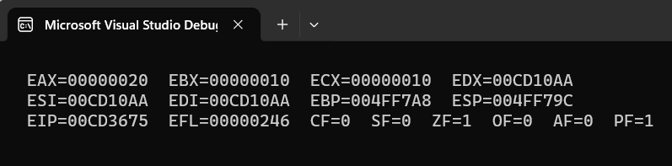

TASK 2:
;Task 2 lab 1
mov eax, 0
mov ebx, 0
mov eax, 15
mov ebx, 25
add ax, bx

call writeint ;picks values from eax
;call DumpRegs

OUTPUT:
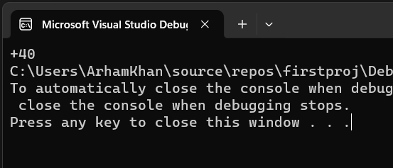

TASK 3:
;Task 3 lab 1
;mul multiply the register with the value written in eax
mov eax, 5
mov ebx, 8
mul ebx
call writeint
OUTPUT:
